Assignment - 2 (Day 5)

Name : GOKUL J B

Email id : jbgokul2000@gmail.com

Question

1. Add a 10GB disk to the CentOS.

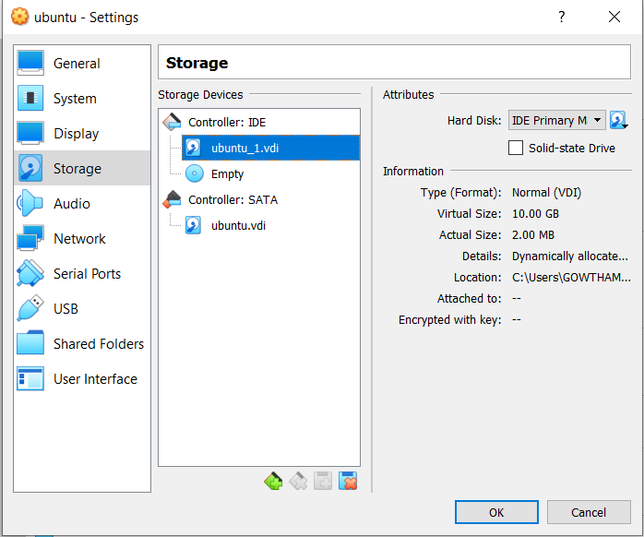

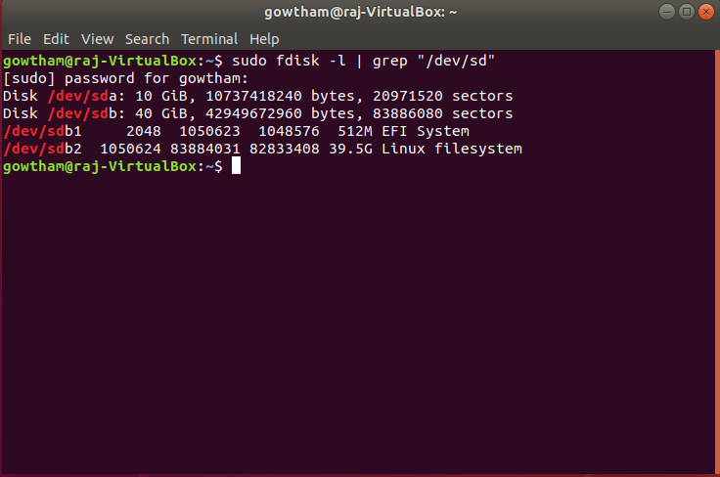

1. Create 2 Partitions 4GB and 6GB of Space respectively.

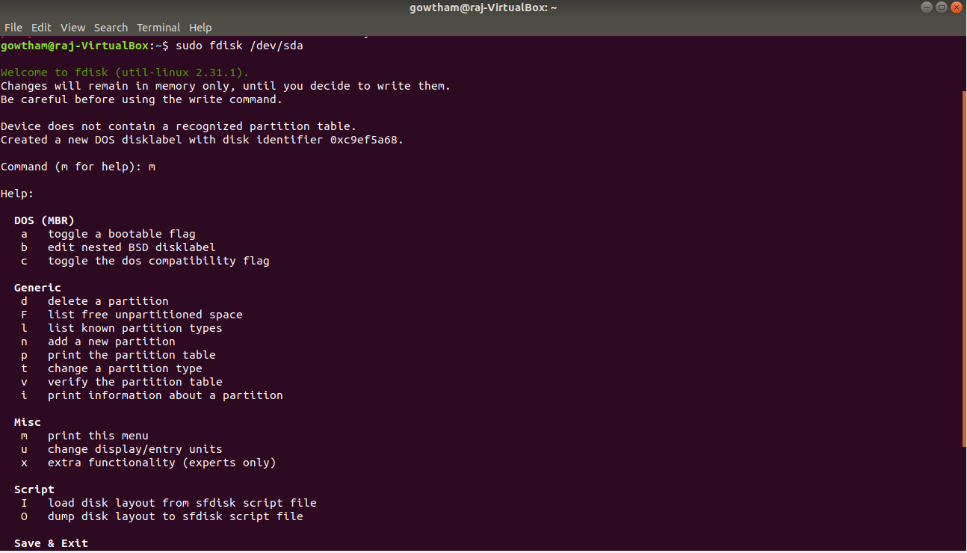

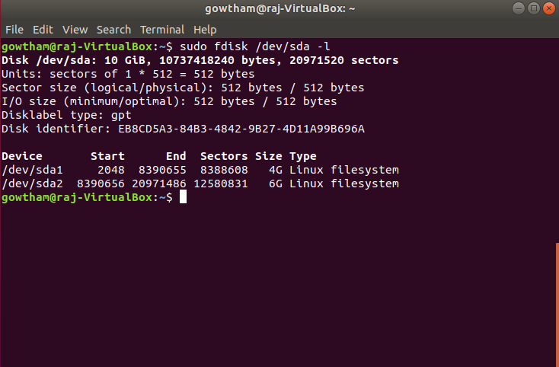

1. Format 4GB with xfs and 6GB with ext4 file system.

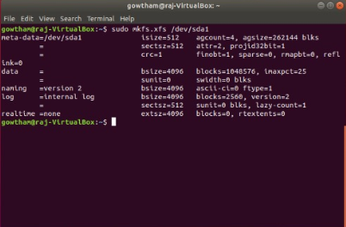

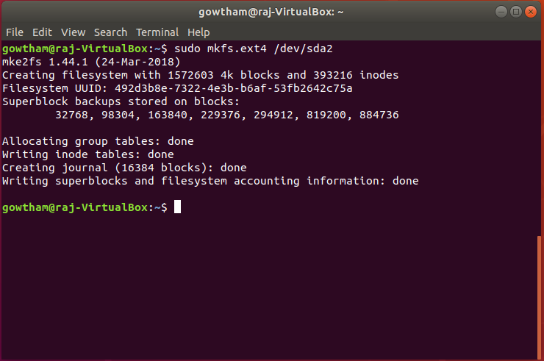

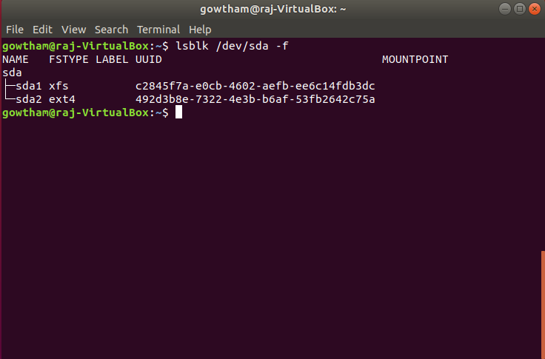

1. Mount 4GB and 6GB in /data and /music directory respectively.

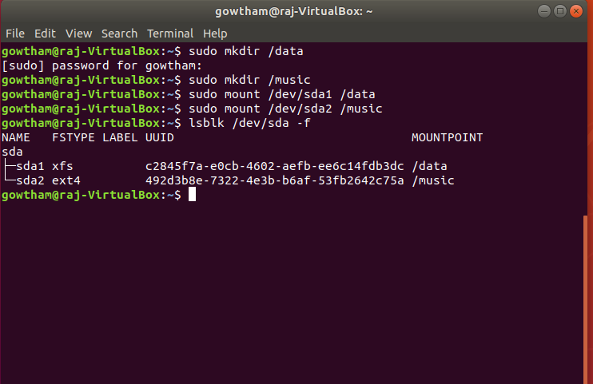

1. Create one file of 1GB in each of the mount point created above.

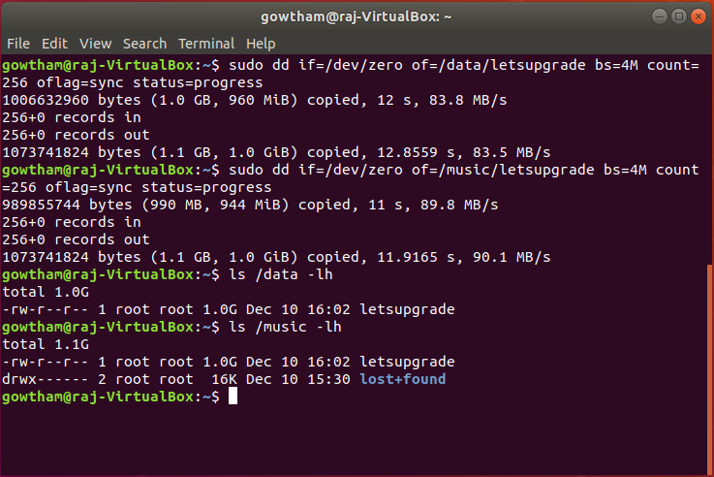

1. Verify the disk Consumption and disk space free in the mounted partitions.

